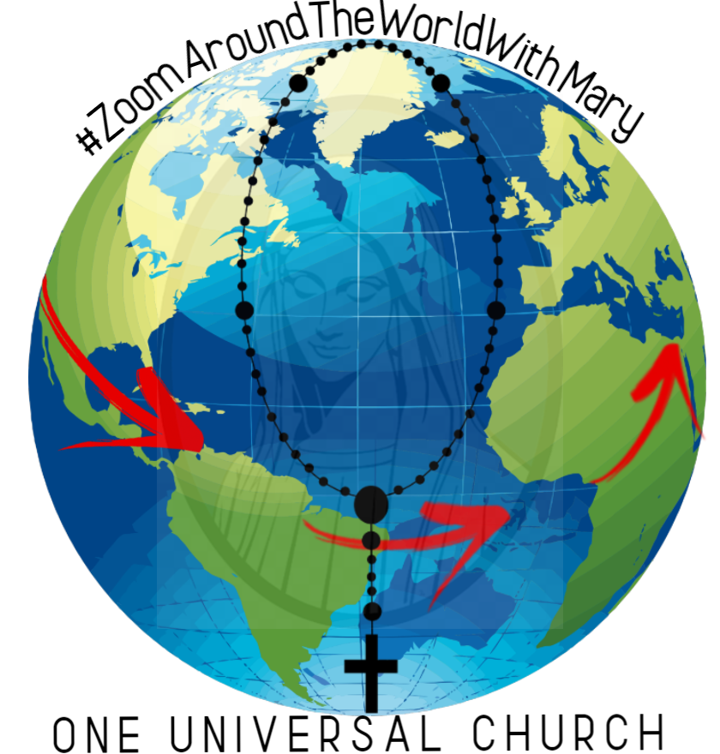
The Holy Father’s letter calling for families to pray the rosary at home invites us to come together as one family, one church and one body of Christ. The concept of Zoom around the world with Mary began with the vision to bring young people from our diocese and different parts of the world to pray together at the same time throughout the month of May.

At World Youth Day 1995, St. Pope John Paul II called the Church to become the “traveling companion to young people.” Twenty-five years later it is the young who are accompanying the church in using their unique gifts and technology to come together to pray and grow in faith.

Zoom around the world with Mary is a worldwide rosary initiative for the month of May with young people around the world. Each gathering will be focused on a different theme of global solidarity and Laudato Si.

Gatherings
The Zoom platform will be used to host the gathering for the first 100 participants and young people leading the virtual gathering. The rest of the participants will be directed to participate in the livestream that will be hosted in the YouTube platform.

This live zoom on YouTube will be approximately 30 minutes. A virtual faith sharing space for the young people who participated in the livestream will take place after the live session. This faith sharing experience will also be 30 minutes long. The total gathering session will be one hour and will be hosted weekly on Friday evenings or Saturday mornings for the month of May (5 Sessions).

Layout of the Live Stream Session:
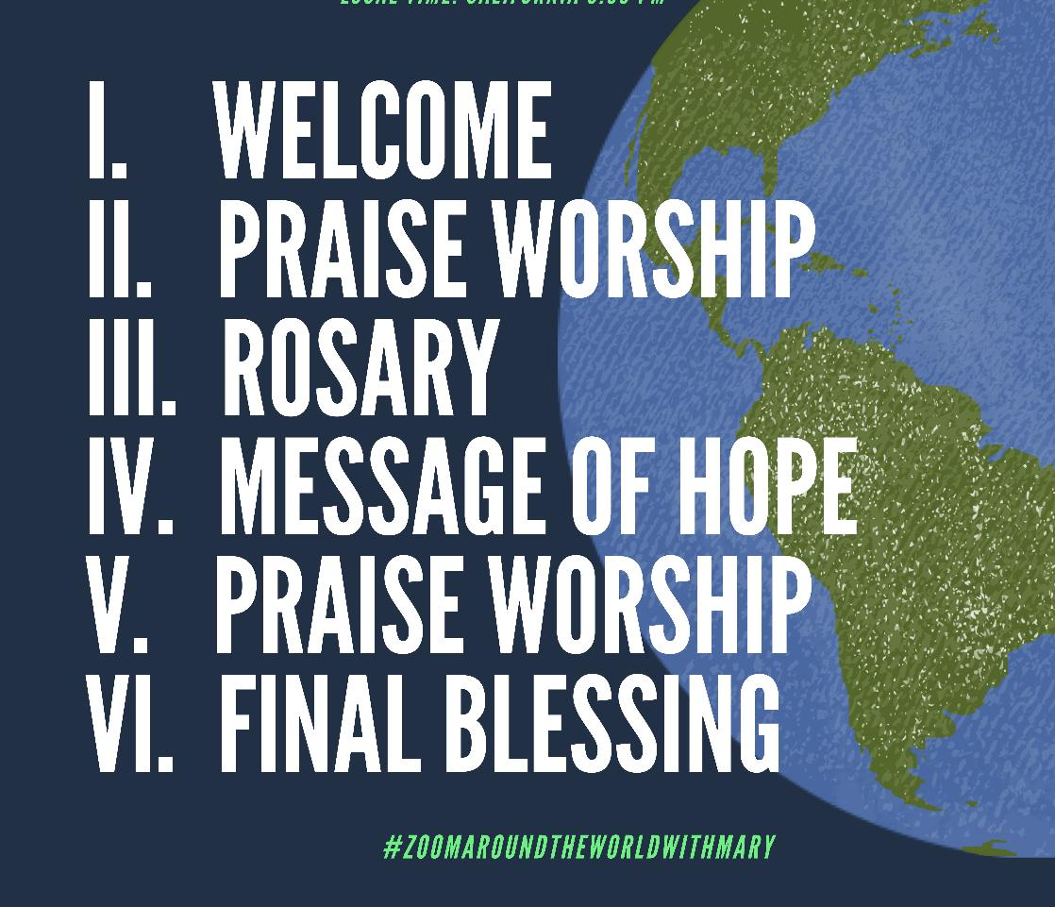
- It will begin with a song by a local band or choir from around the world
- Opening prayer and a short message by a priest regarding the theme of that session (Global Solidarity or Laudato Si) will follow
- All will pray the rosary together
  - Rosary starts with the young people of San Bernardino
  - Each decade of the rosary will be led by a young person from a different country and prayed in their own language.
  - The final prayers will be led by young people of San Bernardino

- the rosary, a message of hope from a young person from around the world will take place
- The session will close with a song and a final blessing by a priest
- As a follow-up to the weekly experience, an activity for that week will be provided to the young people and their families for faith sharing during the week. These resources will be placed in the Bernardine Hub in our diocesan webpage.

Organizers
This Initiative came from the young people of our parish communities and their youth ministry leader. OMYC Director is collaborating and assisting this group in their efforts. Among the organizers are the following communities and their respective young adult leaders:

St. Mary, Fontana
Rev. Arturo Aguilar, Priest in residence at St. Mary’s
Arnel Recio
Sarah Dingler, Coordinator of Youth Ministry
Karla Osio Vargas, Sub-Coordinator of Youth Ministry
David Anthony Guzman
Diego & Elizabeth Gamboa
Victoria Ciudad Real, Coordinator of High School Ministry

St Oscar Romero Catholic Community
Tony Pimentel, Coordinator of Youth Ministry

Holy Innocents, Victorville
Molly Lohnes
Rigoberto Correa

St. Frances of Rome, Wildomar
Celeste Garcia

St. Adelaide, Highland
Rev. Alex Rodarte

Outreach & Engagement
- Social Media posts, stories in various Ministries accounts
- Facebook Lives, Instagram Lives
- Videos & Personal Invitations

Schedule for the First two Sessions
MAY 1-2 Friday/Sat | 09 PM PDT | 11 PM GMT-5 | 6 AM CEST  Saturday | 7 AM EEST  Saturday | 12 PM PST  Saturday | 1 PM KST  Saturday
Intro: Arnel Recio  Priest: Fr. Arturo Aguialr  Youth Speaker:  Victoria Ciudad-Real  Music: Parousia Band  Announcement:  Tony Pimentel | San Bernardino  (St Mary) | Colombia/  Peru | Barcelona,  Spain | Athens, Greece | Manila, Philippines | Seoul, South Korea
May 9 Saturday | 08 AM PDT | 10 AM CST | 12 PM GMT-3 | 5 PM CEST | 11 PM GMT+8 | 11 PM HKT
Intro: Arnel Recio  Priest: Fr. Alex Rodarte  Youth Speaker:  Tony Pimentel  Music: Pending  Annocents: Arnel Recio | San Bernardino  (St Oscar Romero) | Costa Rica  El Salvador | Fortaleza, Brazil | Basque, Spain | Singapore | Hong Kong

